- Creating the database and table

      - Using Command Prompt

Create database `mysitedb`;

Use mysitedb;

Create table ‘user_info’

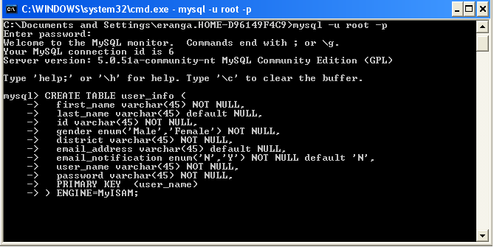

- Using Query Browser

Write click on the schemata tab and click on the ‘Create New Schema’ option.
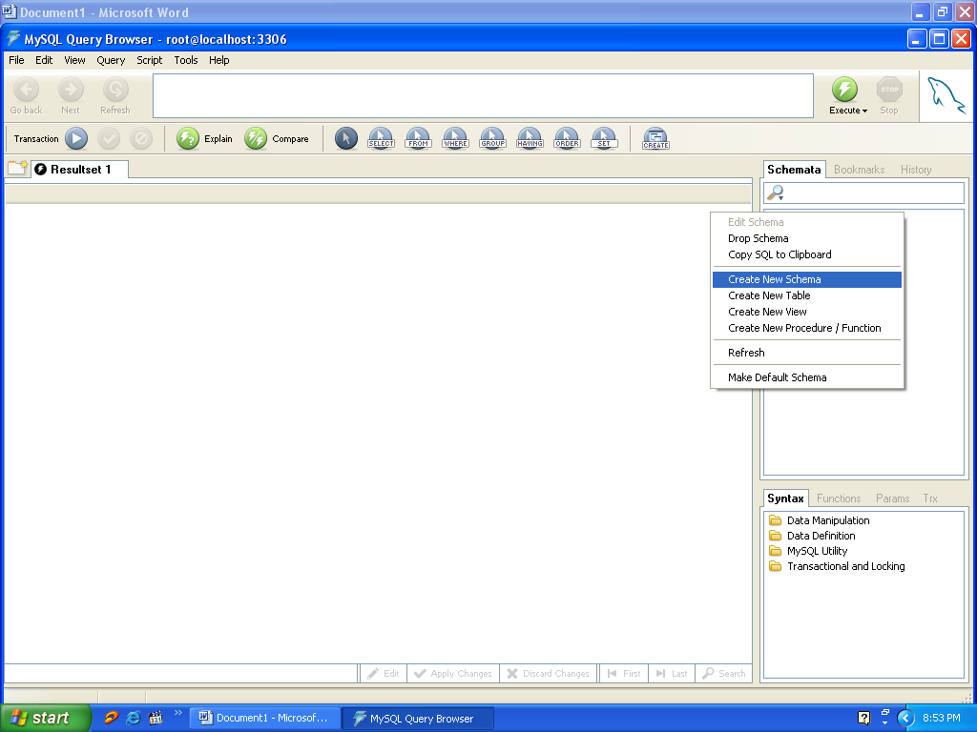

Inside the textfield, give your database name and click ‘Ok’.

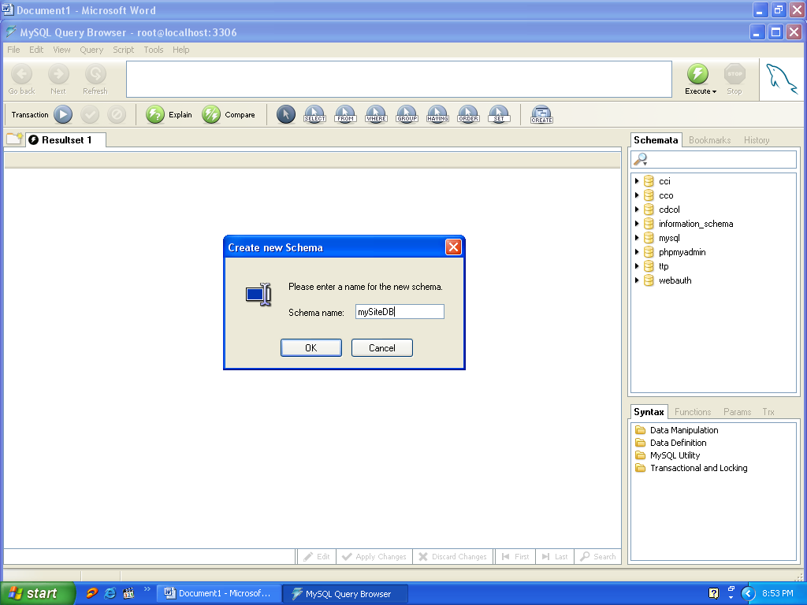

Write click on the database name (“mysitedb”) and click on the ‘Create New Table’ option.

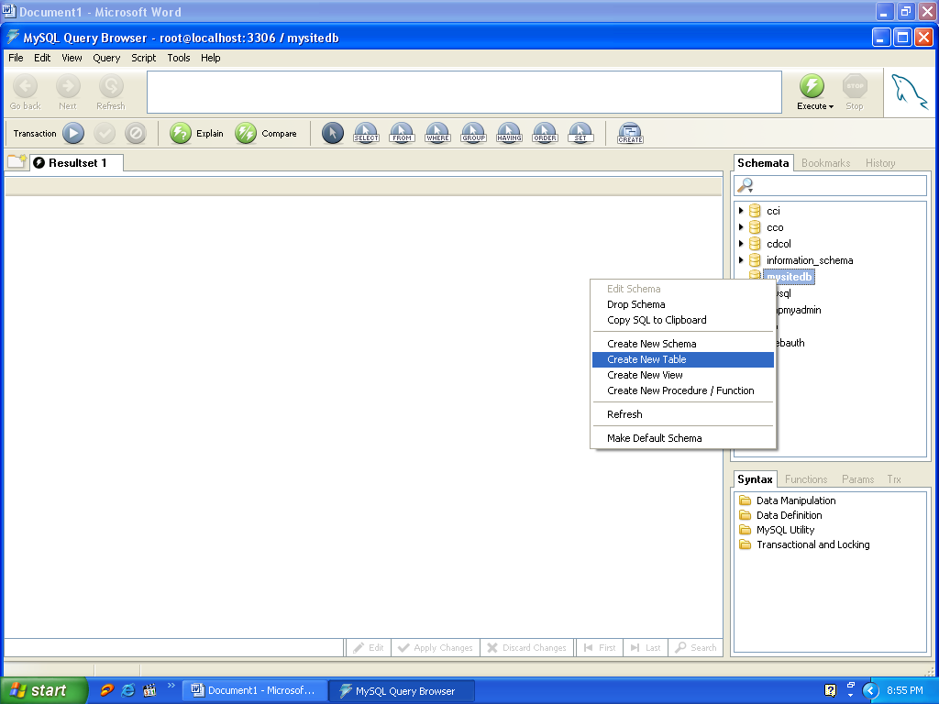

Create table ‘user_info’

